Available online at [www.sciencedirect.com](http://www.sciencedirect.com/)



AASRI Procedia 3 (2012) 700 – 706

2012 AASRI Conference on Modeling, Identification and Control

A novel Compact Bio-filter System for a Down-draft Gasifier : An Experimental Study

R.Rameshkumara, K.Mayilsamyb

*a Faculty of Automobile Engineering, K.S.R College of Engineering, Tiruchengode-237215, TN, India*

*b Faculty of Mechanical Engineering, Institute of Road and Transport Technology, Erode-638 316, TN, India.*

Abstract

A major problem in biomass gasification is tar formation which in subsequent stages decomposes under the conditions such as temperature, pressure drop, gas flow rate etc.. The potential of proposed compact Bio-filter for gas cleaning system analyzed here is excellent for reducing the tar content and particulate in producer gas. Critical review of literature reveals that all existing system have a maximum tar removal capacity of 90%. However, an exemption, catalytic crackers have efficiency in the range of 90 to 95% ,but it operates at very high temperatures (900°C).In this work, an attempt has been made to develop an efficient comapct filter system and analyze its performance characteristics that operates in a low temperature range of 50-70°C, which will be convincing when compared with other system. The performance of developed compact Bio-filter was successfully tested with a 20 kW open core downdraft TNAU-SPRERI's gasifier. Results claim maximum tar reduction rate, than any other system reported and its magnitude varies from 93% -97%. Moreover, the experimental results reveals that tar and particulate content is converged to 52 mg/Nm3 from an initial range of 1680 mg/Nm3 claiming an efficiency of 97%, thereby useful for reducing the engines wear and tear.

© 2012 The Authors. Published by Elsevier B.V. Open access under [CC BY-NC-ND license.](http://creativecommons.org/licenses/by-nc-nd/3.0/)

© 2012 Published by Elsevier B.V. Selection and/or peer rev[iew under responsib](http://creativecommons.org/licenses/by-nc-nd/3.0/)ility of American Applied Science Research Institute

Selection and/or peer review under responsibility of American Applied Science Research Institute

*Keywords :gas cleaning; tar and particulate removal; biomass gasification.*

1. Introduction

Biomass energy constitute a major role in global energy supply from renewable source as it contributes 67.86% of the current energy levels. [Rogner et.al.,2000]. Tar content in producer gas is undesirable which makes pavement for serious problems in the the IC engine applications. [Parikh et.al.,1995]. Numerous works

* Corresponding author. Tel.: +91-9842399523; fax: +91 4288 274757

*E-mail address:* [rameshsumi@gmail.com.](mailto:rameshsumi@gmail.com)

2212-6716 © 2012 The Authors. Published by Elsevier B.V. Open access under [CC BY-NC-ND license.](http://creativecommons.org/licenses/by-nc-nd/3.0/) Selection and/or peer review under responsibility of American Applied Science Research Institute doi:10.1016/j.aasri.2012.11.111

have been reported in the view to reduce the wear of the engine[Kuapp et.al.,1984]. The magnitude of tar and particulate content in the producer gas was postulated as less than 100 mg/Nm3 and less than 50 mg/Nm3 respectively for IC engine applications.[Bhatacharya S.C et.al.,1999].

Small-scale gasifiers use physical tar filters and large-scale commercial gasifiers make use of other typical methods for tar removal.[Ramadhas A.S et.al.,2005; Pathak.B.S.et.al.,2007; Devi.L.et.al., 2002]. Various gas cleaning system developed by different researchers include filter materials such as wet scrubbers [ Neeft.JPA.et.al.,2002], fabric [Dasappa.etal.,2004], electrostatic precipitators [Van paesan et.al.,2004], ceramics [Wiedren de Jong et.al.,2003] and sand bed [Mukunda et.al.,1994] separately for their filter design. Very few research work have been attempted for producing tar-free gas at around 30-40°C temperature, for better IC engine efficiency [Spliethoff,2001; Dasappa.et.al.,2003]. Although few filters were implemented for conditioning , appropriate design procedures and operation data lacks clarification.

However, to the author's knowledge design and development of a compact Bio-filter system without pre- heating has not been addressed do far. Moreover, increasing the efficiency beyond 90 % is also a difficult task. In this work, an effort has been made to develop a new compact Bio-filter system, which has a better efficiency.

1. Proposed methodology
   1. *Bio-Materials in Filter design*

The major constituents of compact gas cleaning and cooling system comprises are Wet scrubber, Wet charcoal and Dry coconut coir. All the dimensions of three different filter sections were calculated based on producer gas generation rate, flow rate, velocity in the filter, and retention time.

The design parameters are calculated and listed in Table 1. for three different sections. The schematic layout of the newly developed filter set up is illustrated in the Fig. 1.

Table 1. Filter design parameters

Parameters/ Stage Filter

Section I

Filter Section II

Filter Section III

sec m

|  |  |  |
| --- | --- | --- |
| Retention time, 3.5 | 11.0 | 7.0 |
| Filter Bed Height, 0.8 | 0.5 | 0.6 |
| Velocity of gas, 0.229 | 0.045 | 0.086 |
| Gas flow rate,m3/h 38.0 | 38.0 | 38.0 |
| Filter Diameter,m 0.24 | 0.54 | 0.40 |

m/sec

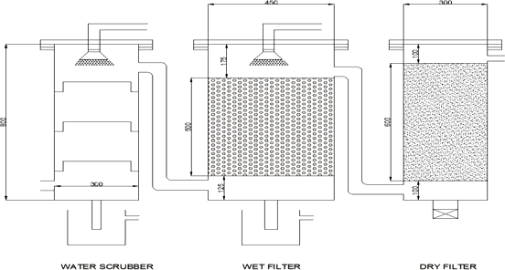

Fig 1. Schematic layout of the newly developed filter set up

* 1. *State-of-Art Method*

The bio materials used in the compact Bio-filter system for three different layers are wet scrubber, wet charcoal and dry coconut coir with different dimensions. In the first section, the raw producer gas is collected, and cooled by the counter water flow which removes most of the dust particles and limited quantity of tar. Then the gas is expanded and its velocity is reduced to remove the tar which is settled in filter bed of the second section. The last section is used for condensing the moisture content of gas and removing the tar left behind.

* 1. *Experimental Set-up*

The novel compact gas cleaning and cooling system was designed, developed and tested with an existing 20 kW open core downdraft gasifier at Tamil Nadu Agriculture University, coupled with an IC engine for testing various performance characteristics. The wood chip consumption rate for supplying producer gas lie between 1 and 1.2 kg/kWh [Mandwe et.al., 2006]. Approximately 1.8 - 2.0 Nm3/h of producer gas is generated per kg of biomass input. Table 2.presents the parameter specification.

Table 2. Filter design specifications

Parameters Value

Woodchip dimension Length:3.0 - 3.5 cm; Width: 2 - 3 cm

Woodchip Consumption 20 kg/h

(20kW X 1 kg/kWh )

Gas generation rate 38 m3/h

(20kW X 1.9 Nm3/h)

Gas Flow rate 38 m3/h

The generated producer gas is sent to the compact gas cleaning and cooling system for removal of tar and dust particulates. U-tube Manometers and hot wire Anemometer were utilized to measure variation in the gas flow rate and the pressure drop across the filter respectively. A Micro DAQ K type Chromel - Alumel Thermocouple and RTDs were installed to measure the flame and gas temperature respectively. An unique system in zigzag nature, made up of copper material is being immersed in water at an temperature range of 3- 6˚C, is used as an tar condenser. Gas sampling measurement was accomplished with an iso kinetic sampling train activated by a single phase vaccum pump and a blower. A gas chromatograph was used for analysing the composition of gas at outlet. A single cylinder four stroke Internal Combustion Engine was provided for power generation. The experimental set up is shown in the Fig 2.

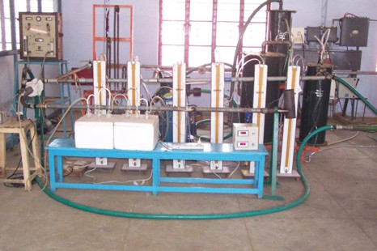

Fig 2. Experimental test rig

1. Results and Discussion.

The novel compact Bio-filter system was extensively tested to evaluate major performance parameters like gas inlet and outlet temperature at each filter layer, pressure drop across the filter, tar content and particulates in the producer gas at inlet and outlet and tar reduction. The measurements were taken in a time interval of 20 minutes. The experimental results of measured performance parameters are tabularized as shown in Table 3. From the results it is obvious that the tar and particulate content significantly reduces with the time due to deposition of tar in the filter.

Table 3. Experimental results.

*Gas Temperature (*°c*)*

*Pressure drop (mm H2O)*

Tar and Particulate *(mg/N m3 )*

Tar reduction (%)

*S.No* Time

(pm)

*Inlet Water*

*Scrubbe r*

*Wet charcoal Exit*

*Outlet Initial Final*

|  |  |  |  |  |  |  |  |  |  |
| --- | --- | --- | --- | --- | --- | --- | --- | --- | --- |
|  | | | *Exit* |  | | | | | |
| 1 | 2: 40 | 260.42 | 166.21 | 78.86 | 51.22 | 18 | 1678 | 59 | 96.66 |
| 2 | 3.00 | 282.34 | 191.34 | 83.17 | 54.81 | 19 | 1439 | 58 | 95.96 |
| 3 | 3:20 | 301.83 | 204.68 | 89.02 | 58.74 | 21 | 1148 | 56 | 95.12 |
| 4 | 3:40 | 329.56 | 229.46 | 94.50 | 62.38 | 22 | 966 | 53 | 94.51 |
| 5 | 4:00 | 352.10 | 247.90 | 99.20 | 65.93 | 24 | 801 | 52 | 93.51 |
| 6 | 4:20 | 376.62 | 271.44 | 105.42 | 68.84 | 25 | 699 | 52 | 92.56 |

Fig 3. shows the variation of pressure drop across the filter with respect to time. It can be observed that the pressure drop increases with time. Moreover, the pressure drop is low in the first two filter layers when compared with the third one, as the diameter of the filter increases in the newly proposed design .

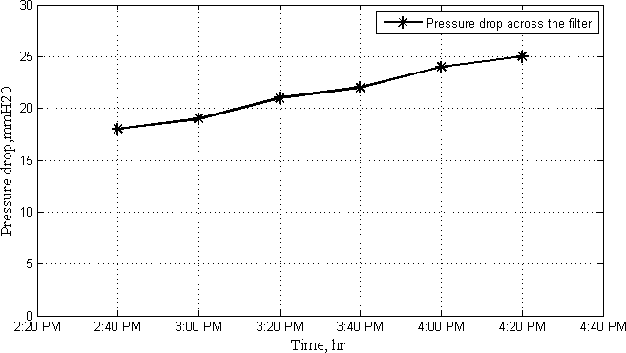

Fig 3. Pressure drop across the filter

The variation of gas inlet and outlet temperature of the filter with respect to time is shown in the Fig 4. From the graph ,it can be observed that for an increase in the inlet temperature there is slight proportional increase in the outlet temperature. However, there is high temperature drop in the first two sections due to the spray of water to condensate the tar and particulates.

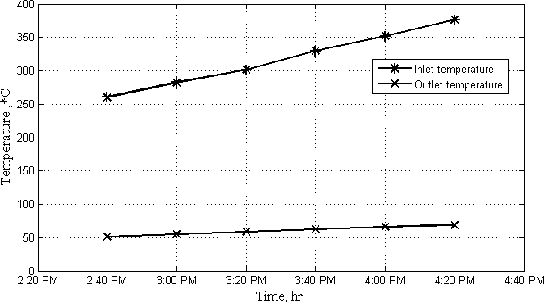

Fig 4. Temperature of the producer gas

The variation of final tar content with respect to temperature is shown in the Fig 5. The final tar and particulate content can be observed to vary slightly for a small variation in the outlet temperature.

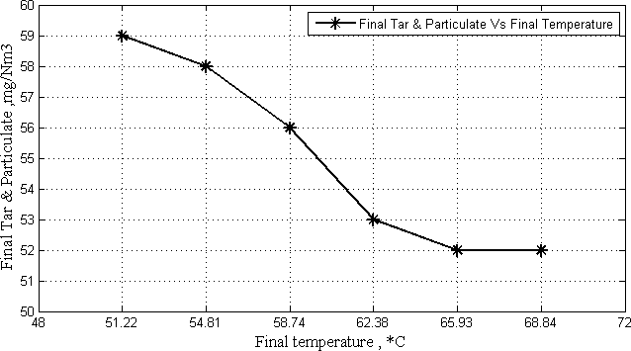

Fig 5. Final Tar content Vs Temperature.

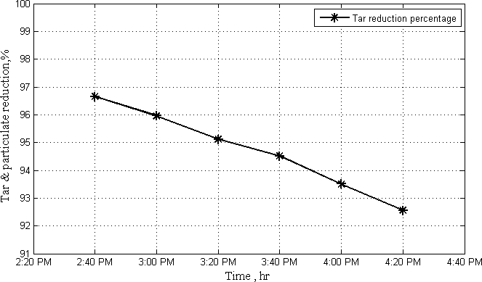

Fig 6. Tar reduction Percentage

Fig 6. shows the tar and particulate reduction with respect to time. The tar reduction efficiency of the compact Bio-filter system can be observed to vary between 93 and 97%. The tar and particulate reduction of this study have been compared with the published literature on similar studies which used other filter methods are given in Table 4.[Hasler et.al.,1998].

|  |  |  |  |
| --- | --- | --- | --- |
| Table 4.Comparision of different filter system. |  | | |
| Gas cleaning system | Temperature *(*° C*)* | Particle reduction  (%) | Tar reduction(%) |
| Sand bed Filter | 10-20 | 70-99 | 50-97 |
| Wash tower | 50-60 | 60-98 | 10-25 |
| Fabric filter | 130 | 70-95 | 0-50 |
| Wet electrostatic precipitator | 40-50 | >99 | 0-60 |
| Rotational particle separator | 130 | 85-90 | 30-70 |

|  |  |  |  |
| --- | --- | --- | --- |
| Catalytic tar cracker | 900 | 90-95 | >95 |
| Compact Bio-Filter | 50-70 | 93-97 | 92-97 |

The tar and particulate reduction values in this experimental study are better than those of others, which in turn complies with the gas quality requirement [Stassenhen et.al.,1993] for an IC engine application.

1. Conclusion.

The proposed novel compact Bio filter system demonstrated a high rate of success in removing tar and particulate content. This system claims a tar reduction rate of 93-97%, which is far ahead than any other existing methodology in an operating temperature range of 50-70ºC. Hence this gas could be treated as almost pure which in turn is highly effective in operating an IC engine with highest efficiency as the wear and tear is greatly minimized due to the purity of the producer gas.

References

1. Rogner H, Popescu A. An introduction to energy. In:Goldemberg J (Chair), editor. World energy assessment: energy and the challenge of sustainability. New York: United Nations Development Programme. 2000.
2. Parikh PP.et.al., State of art: Report on gasification of biomass. Indian Institute of Technology, Bombay, India.1985.
3. Kaupp A. Gasification of Rice Hulls , GTZ/GATE,P.O.Box 5180,D-6236 Eschborn I,Germany,1984.
4. S.C. Bhattacharya, A.H.Md. Mizanur Rahman Siddique, et.al., A study on wood gasification for low-tar gas production ,Energy, 1999; 285-296; 24.
5. Mukunda HS, Dasappa S.et.al., Gasifiers and combustors for biomass—technology and field studies, Energy for Sustainable Development. J Int Ener Initiative, 1994 ; 27- 38;1-3.
6. Hasler P, Salzmann R,et.al., Method for the sampling and analysis of particles and tars from biomass gasifiers. Biomass for Energy and Industry, 10th European Conference and Technology Exhibition. WuÈ rzburg, 1998;1600-1603.
7. A.S .Ramadhas,S.Jayaraj,et.al., Power generation using coir-pith and wood derived preoducer gas in diesel engines , Fuel processing Technology, 2006; 849-853;87.
8. B. S. Pathak, D. V. Kapatel, et.al., Design and Development of Sand Bed Filter for Upgrading Producer Gas to IC Engine Quality Fuel, J Int Ener, 2007; 15-20;8
9. Lopamudra Devi, Krzysztof J.et.al., A review of the primary measures for tar elimination in biomass gasi cation processes, Biomass and Bioenergy, 2003;125 – 140; 24.
10. Neeft JPA, Knoef HAM,et,al., Guideline for sampling and analysis of tar and particles in biomass producer gases, Pyrolysis and gasification of biomass and waste. Expert meeting.2002.
11. Dasappa .S, P.J. Paul, t.al., Biomass gasification technology- a route to meet energy needs. Current Science, 2004;908-916; 87.
12. Van paesan.S.et.al.,Tar removal with a wet electrostatic precipitator (ESP); a parametric study,Second World conference and technology exhibition on biomass for energy, industry and climate protection. 2004.
13. Wiebren de Jong, Omer Unal et.al.,Biomass and fossil fuel conversion by pressurised fluidized bed gasification using hot gas ceramic filters as gas cleaning. Biomass and Bioenergy, 2003;59-83; 25.
14. Spliethoff, Status of Biomass gasification for power production. J IFRF Combustion, 2001; 02-25; 9.
15. Dasappa.et al.,Biomass gasification- a substitute to fossil fuel for heat application. Biomass & Bioenergy, 2003;637-649; 25.
16. D S Mandwe, S R Gadge,et.al., Design and development of a 20 kW cleaning and cooling system for a

wood-chip gasifier, J Ener in Southern Africa, 2006;65-69; 17- 4.

1. Stassen H.E.M, Strategies for upgrading producer gas from fixed bed gasifier systems to internal combustion engine quality. Biomass gasification: hot-gas clean-up. IEA Bio Gasifi Working Gp, 1993; 33-44.